VA Expands Burial Benefits for Veterans

I know this may be a subject some of us might not feel comfortable talking about but non-the-less, it’s a subject we need to be up to date on.
For eligible Veterans and Family members, VA National Cemetery burial benefits include:
- Opening and closing of gravesite
- Inscribed headstone or markers
- Burial Flag
- Award of the Presidential Memorial Certificate
- Perpetual care of gravesite
For those being placed in private cemeteries, benefits only include:
- Headstone, markers or medallions for the gravesite
- Burial Flag
- Presidential Memorial Certificate
VA also may provide burial allowances to assist with a family member’s burial and funeral costs for those eligible. VA encourages Veterans to consider their ‘end-of-life benefits’ provided by the department. To learn more, visit http://www.va.gov/plan-ahead.
I hope this helps.
Ride Safe,
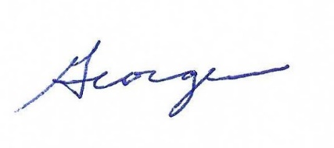
George W. Smith
ALRDOC Service Officer

