American Legion Riders
Department of California
Cup Challenge Rules

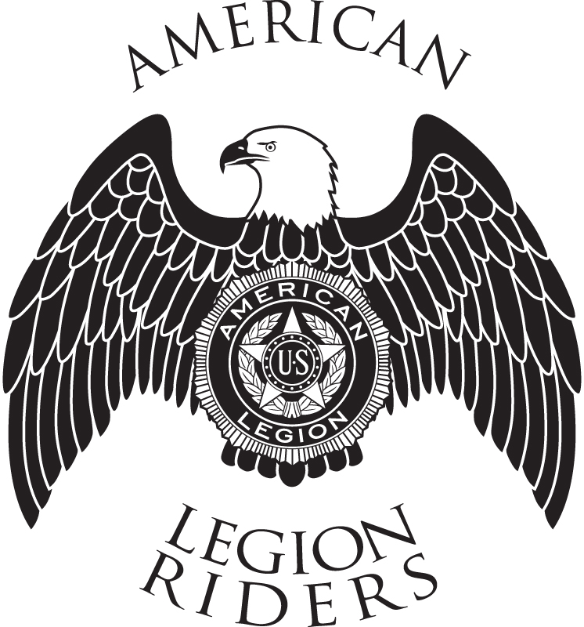

Revised March 2024
The American Legion Riders, Department of California (ALRDOC) Annual Cup Challenge was originally established to encourage all ALRDOC Riders to get out and support the American Legion Family in California and to recognize those ALRDOC Chapters who rode the most miles during the year SAFELY.
The Annual Cup Mileage dates are from April 1 of the previous year to March 31 of the current year (i.e. April 1, 2024 to March 31, 2025)
To participate in the Cup Challenge the following criteria must be met:
- The Chapter/Member must be in good standing.
- Event rides shall support one of the Four Pillars of the American Legion:
  - Veterans Affairs & Rehabilitation
  - National Security
  - Americanism
  - Children and Youth
  - Examples of events that would qualify are
    - Poker Runs in support of Veterans or Veteran supported events
    - Funeral/Flagline
    - Other Post/Auxiliary/Chapter/S.A.L. meals
    - Honor Flight
    - Memorial Day
    - Parades
- All event rides must be within the geographical borders of California.
- Riders who are in ‘Retired’ status can count their miles toward the cup challenge if they travel in a vehicle (cage).
- ‘Social’ or ‘Pop Up’ rides, riding to the members home Post, Chapter, Auxiliary or S.A.L. meeting does not count toward the Cup mileage.
  - This is for two reasons:
    - We all go to our Post/AUX/SAL/ALR meetings.
    - To keep mileage accountable and verifiable, mileage must be restricted to aforementioned criteria.
- If traveling to, during, or traveling from an event a Rider(s) is involved in an accident which is the fault of one or more Riders, the mileage for that day/event only, is forfeited.
- Reporting and Recording:
  - Chapter Points of Contact (POC) are responsible for reporting and recording their Chapter’s mileage on the ALRDOC website.
  - All mileage shall be recorded no later than 2359 hours on March 31. All mileage after said date will not be counted.
  - Area Vice Directors are responsible for reviewing their Area’s Chapter mileage on a monthly basis.
  - All mileage must be logged within 30 days of the event. Subject to review by the Area Vice Director.
- Awards
  - The Mileage Cup will be presented at the Annual ALRDOC Convention by the ALRDOC State Director and the Safety Officer.
  - Certificates will be awarded to chapters who have the most miles in their respective Areas.
- Dispute of mileage
  - Disputes regarding mileage shall be resolved by the ALRDOC Safety Officer or the ALRDOC State Director.
- Mileage Cup rules are subject to review on an annual basis.
- Remember, this is about supporting the American Legion Family and having FUN while doing it!

