American Legion Riders
Department of California
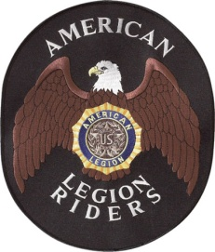
New Chapter Checklist
Chapter #_______ City __________________ Area____
1. Letter to the ALR DOC requesting Chapter approval ________
2. Letter from Host Post # ______ supporting the formation
of an ALR Chapter as a program of the post. ________
3. Copy of meeting minutes of officer elections and approval
of the bylaws. ________
4. Copy of Roster of Members (minimum of 5) ________
5. Copy of Officer Certification (COO) form ________
6. Copy of approved By-Laws ________
7. Copy of Points of Contact (POC) form ________
8. $50.00 Start-up fee paid by PayPal or mailed to ALR Treasurer ________
9. Signature of Area ____ Vice Director ________
The Area Vice Director will review all forms before forwarding them to the Dept. Secretary. Incomplete applications packages will not be presented to the DEC.
____________________ _____________________ _________
Area Vice Director Name-Print Area Vice Director-signature Date

